Essay #1 Assignment
Sedimentology & Stratigraphy
January 28, 2020
(Due on paper by 8:00 a.m. by Tuesday, February 4)

The premise.--You are a newly-hired forensic geologist working for the Federal Bureau of Investigation -- the FBI. Your supervisor brings you a vial of sediment and says, “This sand was found in the boots of a suspected kidnapper. We think it is from wherever he is keeping the victim. We need to know from this sand every detail you can tell us, along with your ideas on what sort of environment it comes from.” The pressure is on as you work quickly but effectively at describing the sediment and supporting your hypothesis for its origin.

The assignment.--Write a full report about this sediment for your non-scientific but intelligent readers. Use all the observations and measurements you made for your unknown sediment sample in lab. The format of the report is up to you, but it must include these items: (It looks like a checklist on purpose!)

___ Color of the sediment
___ Grain size, including:
___ all graphs you constructed
___ mode or modes
___ mean grain size
___ sorting
___ skewness
___ kurtosis
___ Roundness of the grains
___ Mineralogy of the sediment, including estimated percentages
___ Other features (grain shapes, pitting, organic materials, etc.)
___ Two photographs with bar scales, each at a different magnification
___ Your hypothesis as to the source rock or rocks for the sediment (citing evidence)
___ Your hypothesis about the depositional environment (as detailed as possible)

No formulas are required for your readers. Just a brief description of what the various measures indicate. No outside research is required, so no citations. I’ve attached some resources that may help, but for the most part you will be using what you already know about sediment maturity, energy levels, mineralogy and so on. There is no word-count minimum or maximum; just make your report accessible and efficient. We’ve spent three labs getting you ready!

This essay is due by 8:00 a.m. on Tuesday, February 4, on paper. There is no rewrite for this essay – what you turn in is final. Late papers will not be read and simply graded as zero. (Imagine being late for the FBI!) It’s not a bad idea to keep a copy of your working draft in your Dropbox folder. Start early and you will have time to ask questions during Tuesday’s lab next week.

A nice place to begin, by the way, is with Alexis Lanier’s class research paper, which is an example on our website: https://sedstrat.voices.wooster.edu/wp-content/uploads/sites/48/2019/01/example-research-paper.pdf

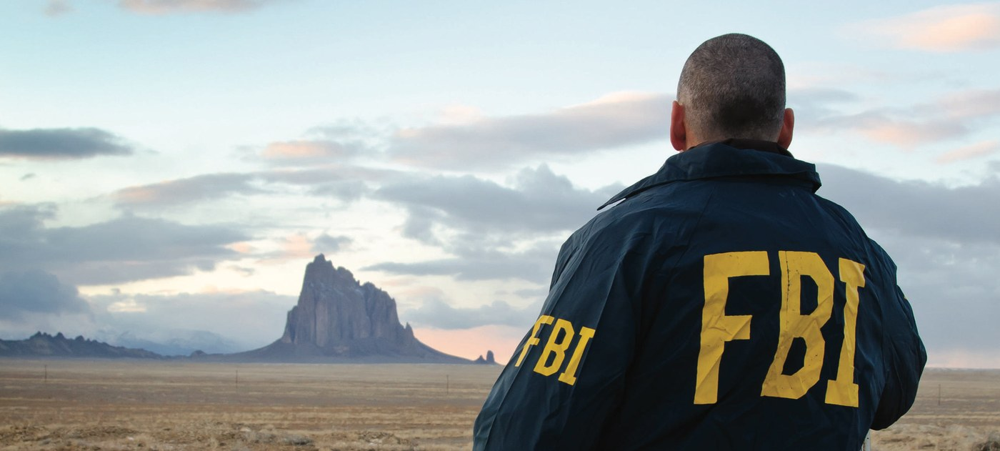

Some random diagrams I found in various papers that may help.
(Ignore any data points that are plotted on them. Some are blurry, alas.)

